**TUGAS AKHIR**

**PEMROGRAMAN BERORIENTASI OBJEK**

**APLIKASI ADMIN SUPERMARKET**

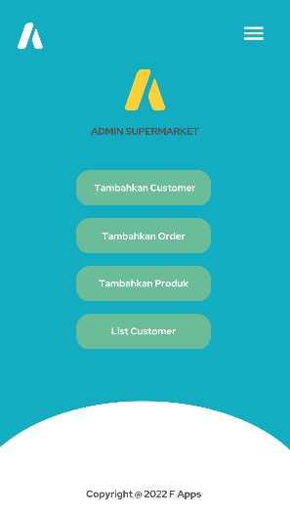

**DISUSUN OLEH :**

**Muhammad Faiz Akbar**

**2100018361**

**Kelas G**

**Link Github:** [*https://github.com/FaizAkbar26/APLIKASI-ADMIN-SUPERMARKET*](https://github.com/FaizAkbar26/APLIKASI-ADMIN-SUPERMARKET)

**PROGRAM STUDI INFORMATIKA**

**FAKULTAS TEKNOLOGI INDUSTRI**

**UNIVERSITAS AHMAD DAHLAN**

**JANUARI 2022**

1. **Deskripsi aplikasi yang akan dibuat**

Dalam aplikasi yang saya buat, aplikasi tersebut akan memiliki pilihan dimana bisa menambahkan customer, yang mana pada menu ini akan melakukan pendataan customer mulai dari nama, alamat, nomor telepon, dan juga email. Kemudian menu kedua ialah menambahkan pesanan, dimana nanti akan memasukkan nama, kemudian kode produk dan juga jumlah produk yang diinginkan.

kemudian menu ketiga ialah melakukan input data barang, mulai dari kode produk, deskripsi, harga. Kemudian pada menu terakhir dapat menampilkan semua data customer dan juga pesanan yang dibuat dan juga total semua pembelian yang dilakukan.

1. **Alur kerja**
2. User dapat memilih pilihan

1. Tambahkan Customer

2. Tambahkan Order

3. Tambahkan Product

4. List Customers

10. Keluar

1. Jika memilih satu maka akan masuk ke program tambah customer
   1. Maka user akan menginputkan nama, alamat, nomor telepon, dan juga email.
2. Jika memilih dua maka akan masuk ke program tambah order
   1. Maka user akan menginput nama, kemudian kode produk dan juga jumlah produk yang diinginkan.
3. Jika memilih 3 maka akan masuk ke program tambah produk
   1. Maka user akan menginput data barang, mulai dari kode produk, deskripsi, harga.
4. Jika memlih 4 maka akan masuk ke program tampilan daftar customer
   1. Maka akan menampilkan menampilkan semua data customer dan juga pesanan yang dibuat dan juga total semua pembelian yang dilakukan.
5. Jika memilih 10 maka akan keluar
6. **Diagram class**

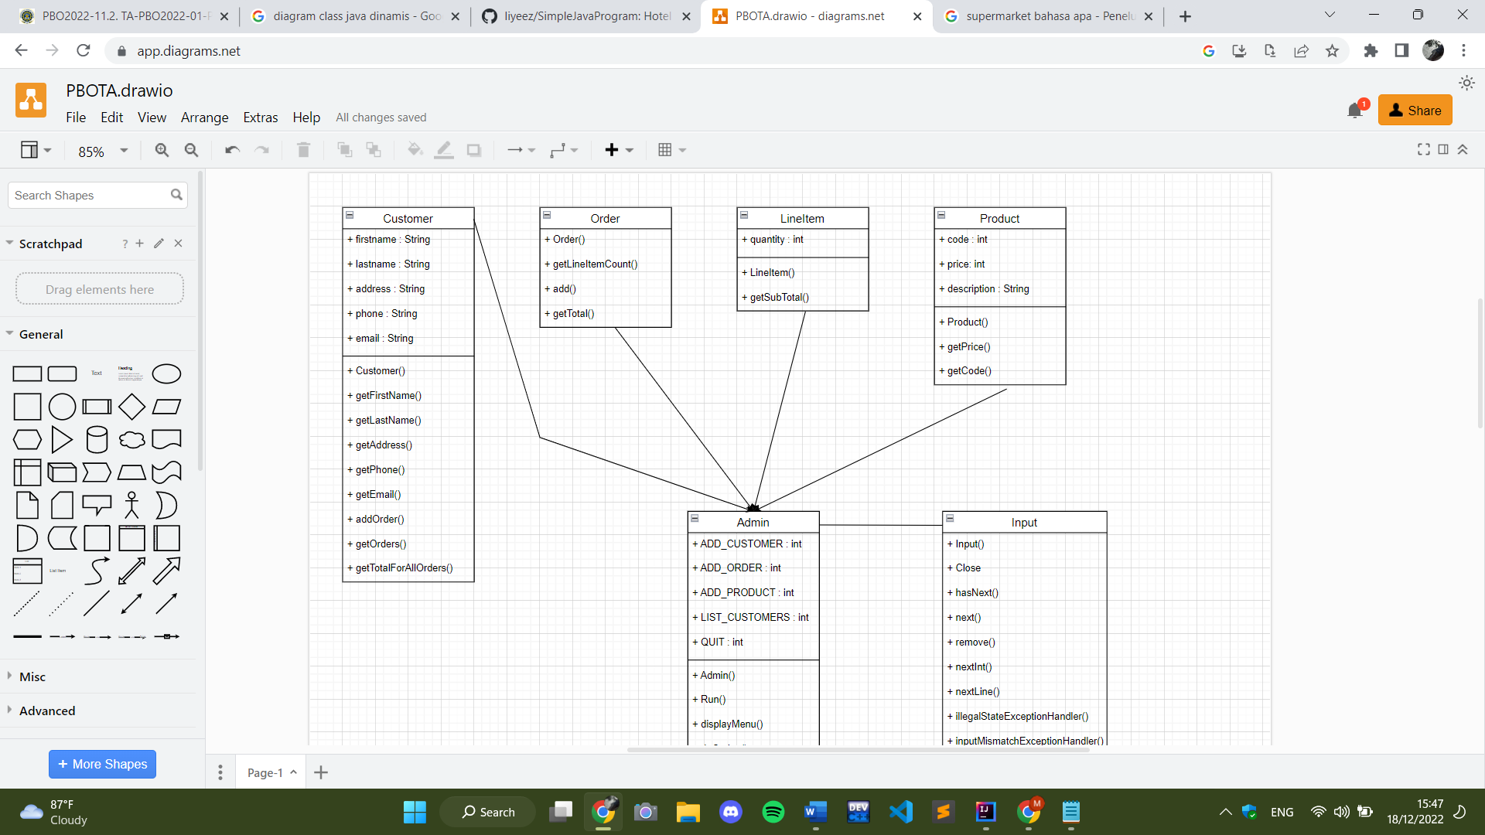

1. **Rancangan antarmuka (UI)**

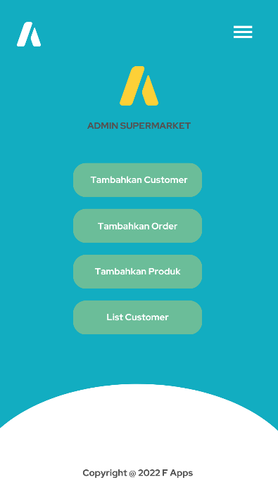

Merupakan tampilan awal dari sebuah menu pada aplikasi tersebut.

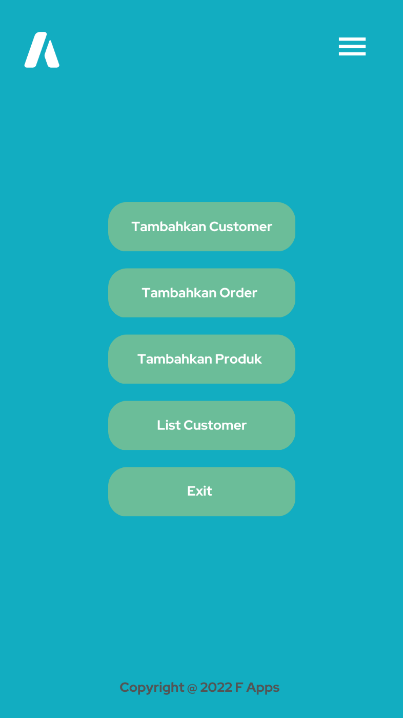

Merupakan tampilan dari bar (3 strip).

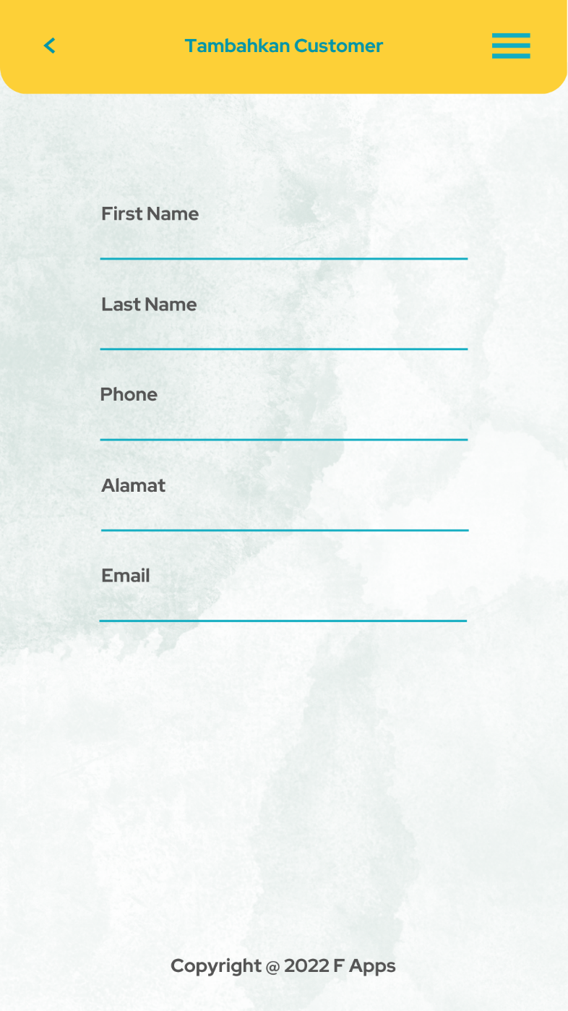

Merupakan tampilan dari menu tambahkan customer.

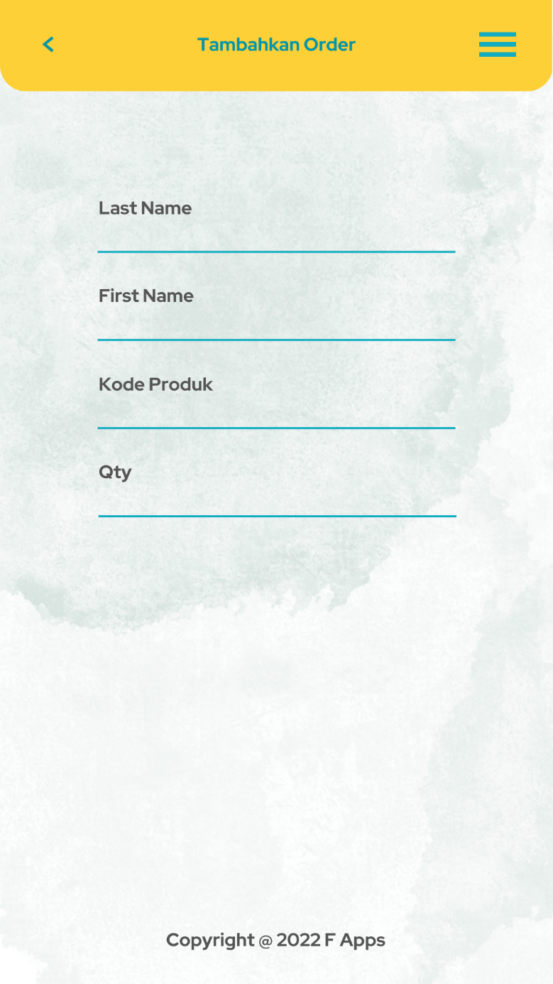

Merupakan tampilan dari menu tambahkan order.



Merupakan tampilan dari menu tambahkan produk.

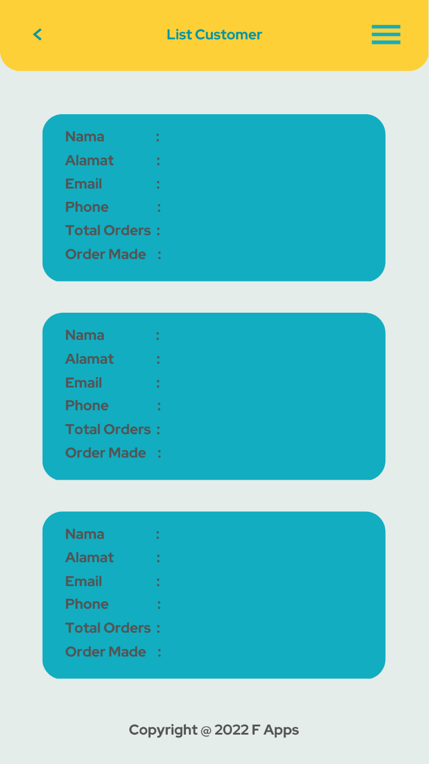

Merupakan tampilan dari list customer.

1. **Implementasi coding Java dilengkapi screenshot coding di IDE yg digunakan**

* Customer.java

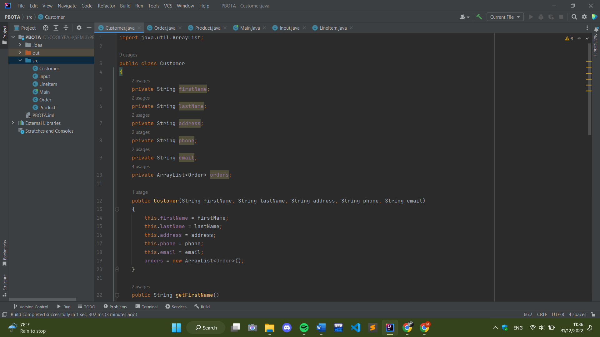

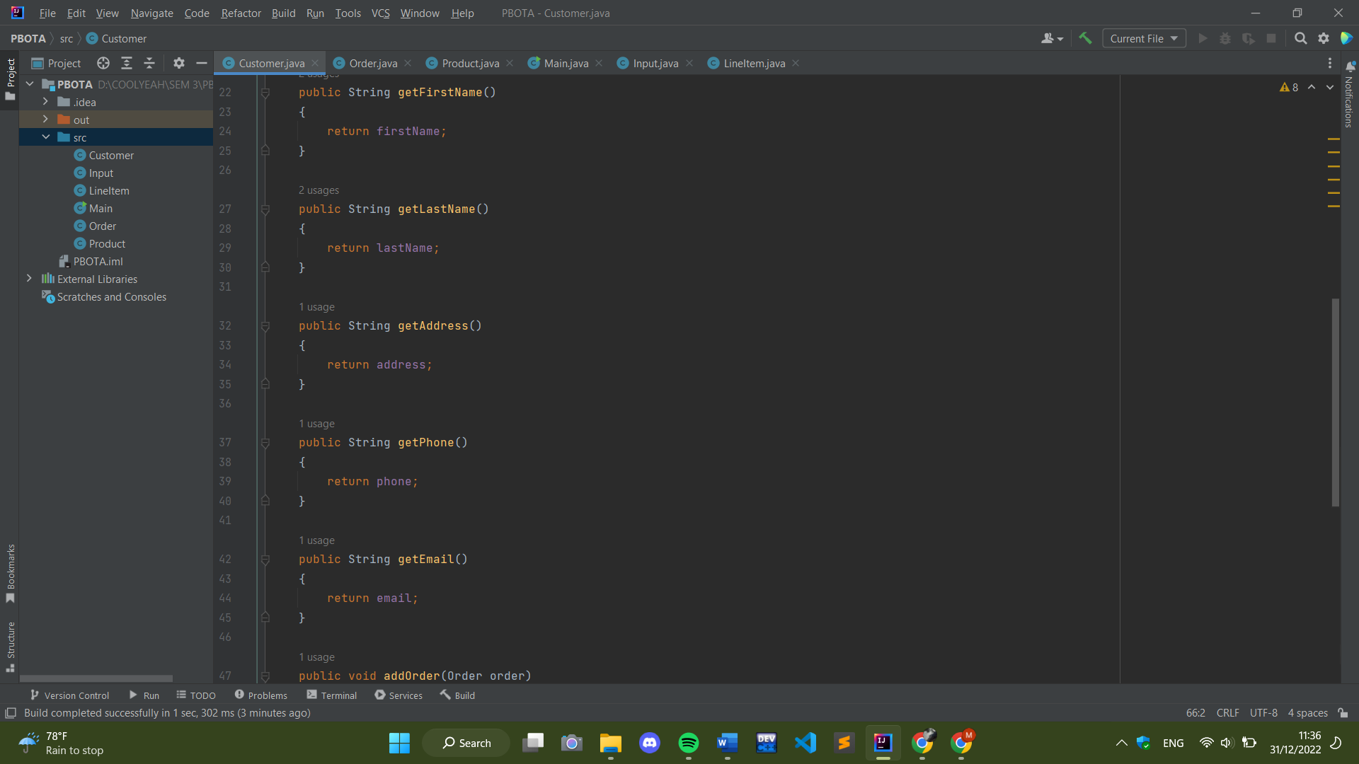

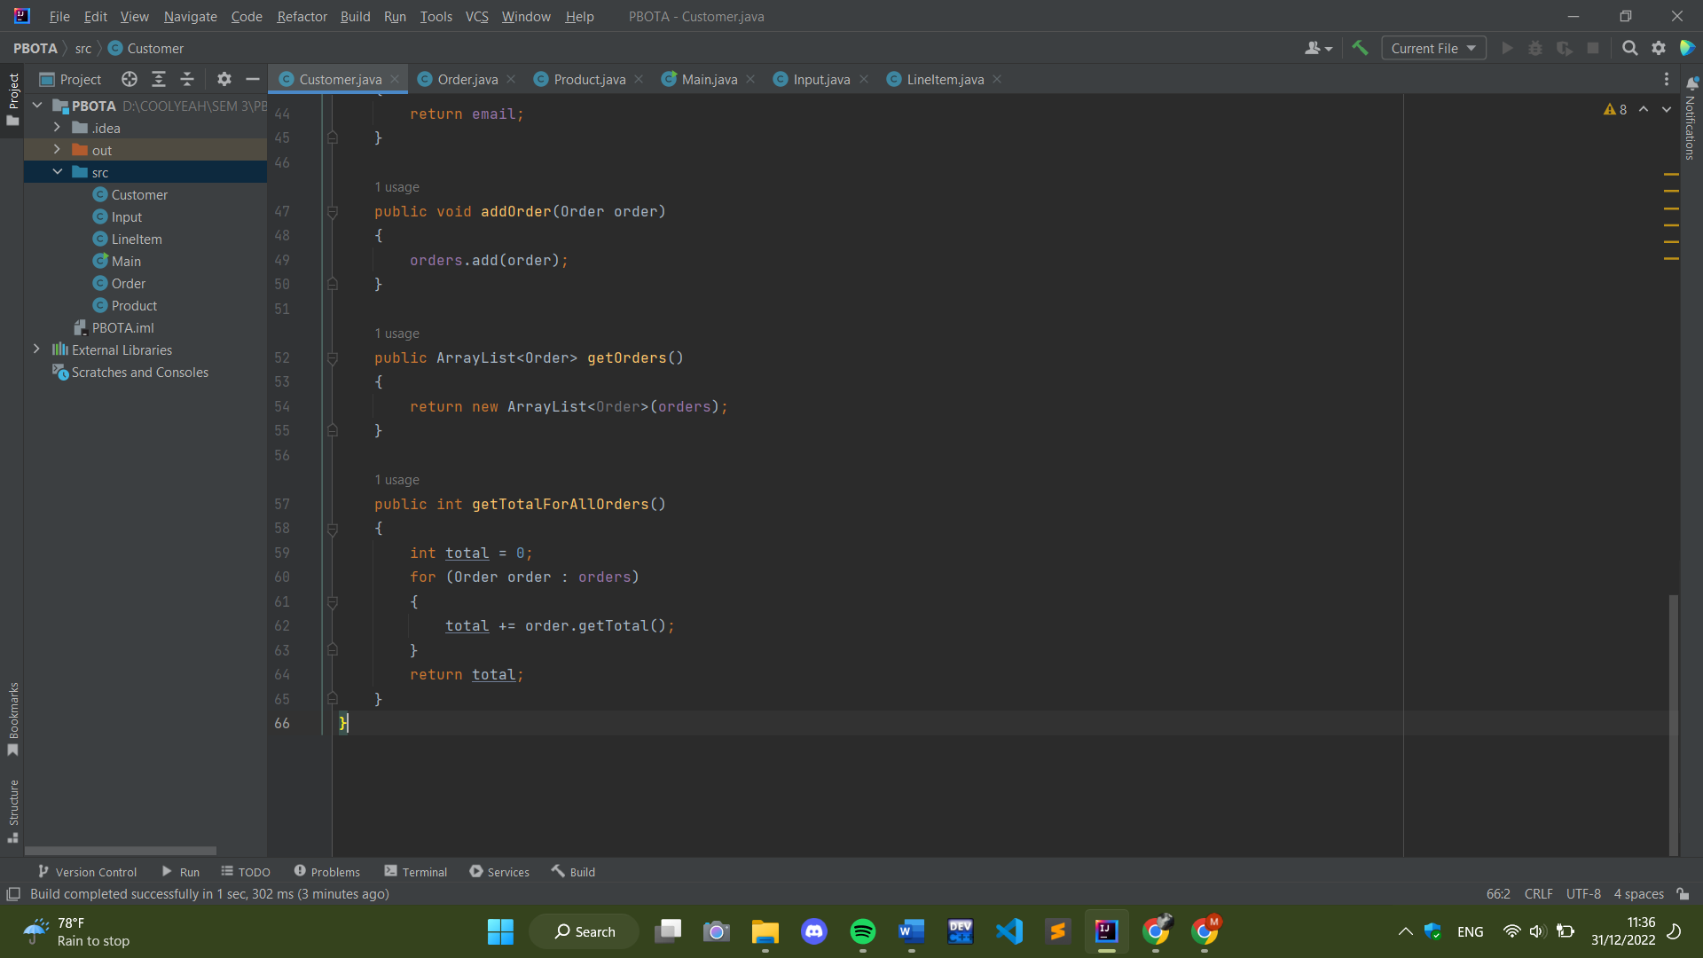

* Input.java

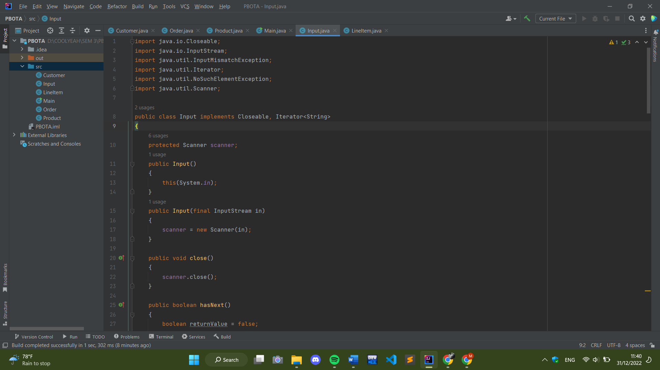

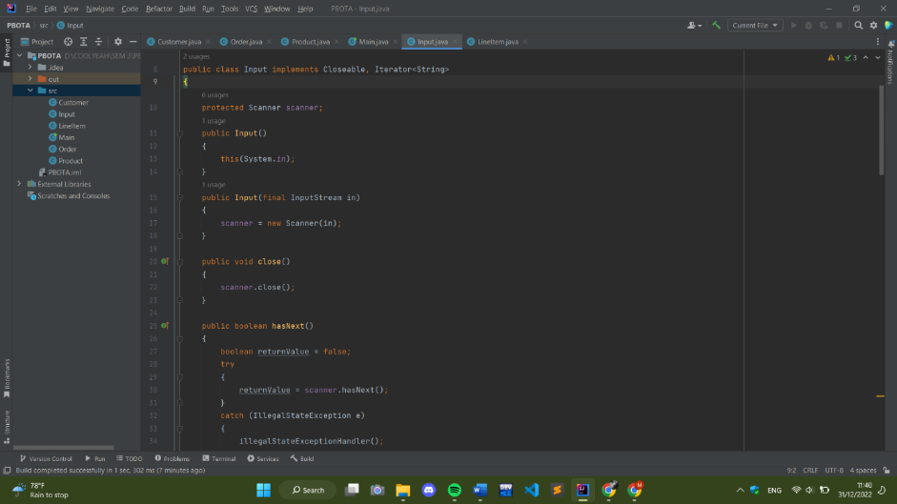

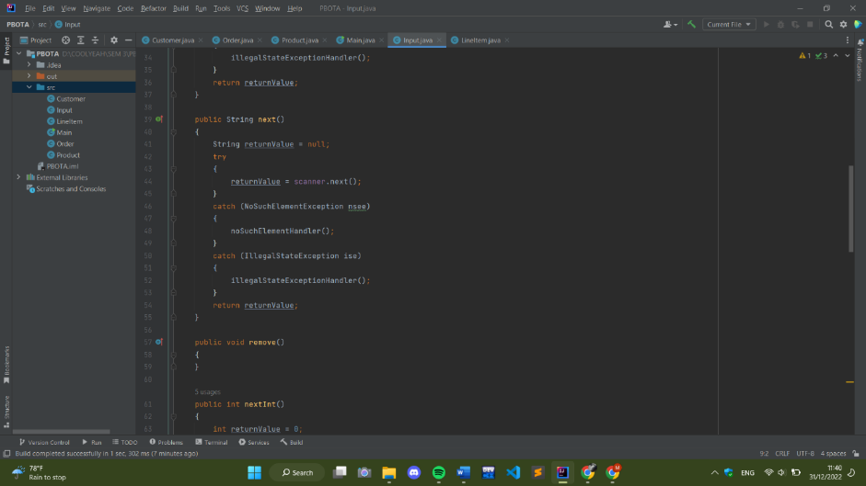

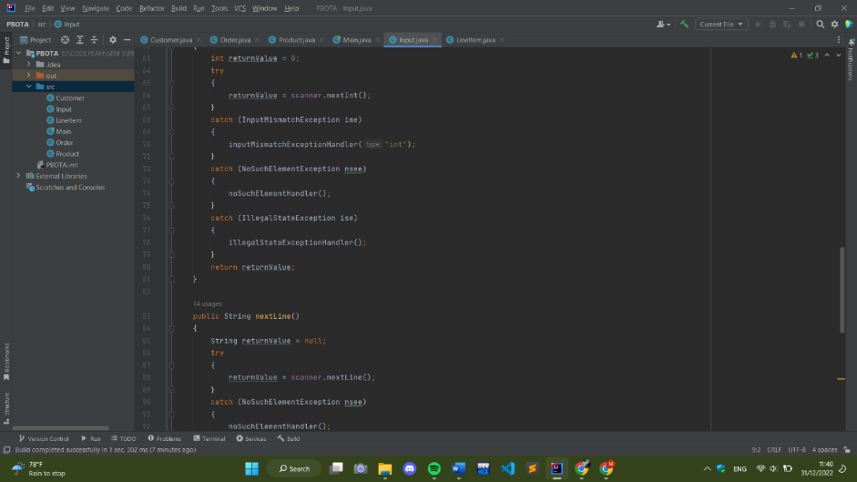

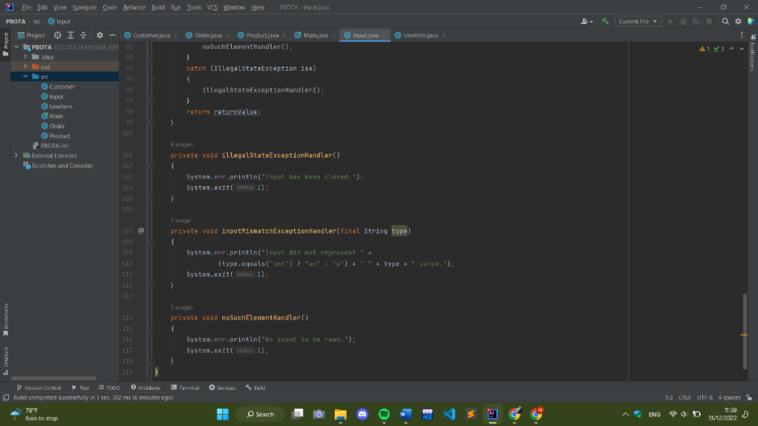

* LineItem.java

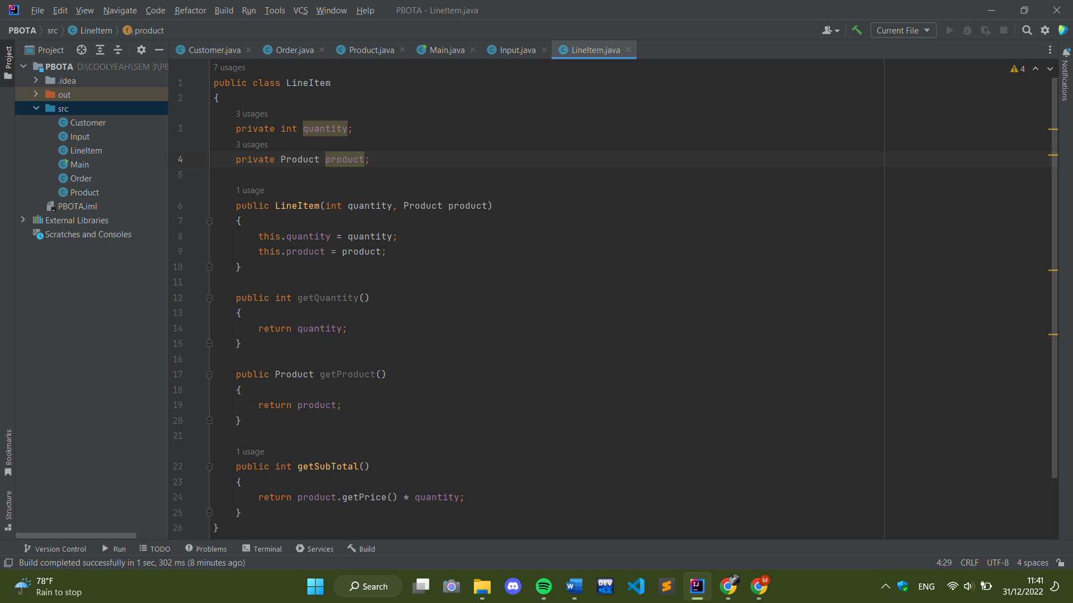

* Product.java

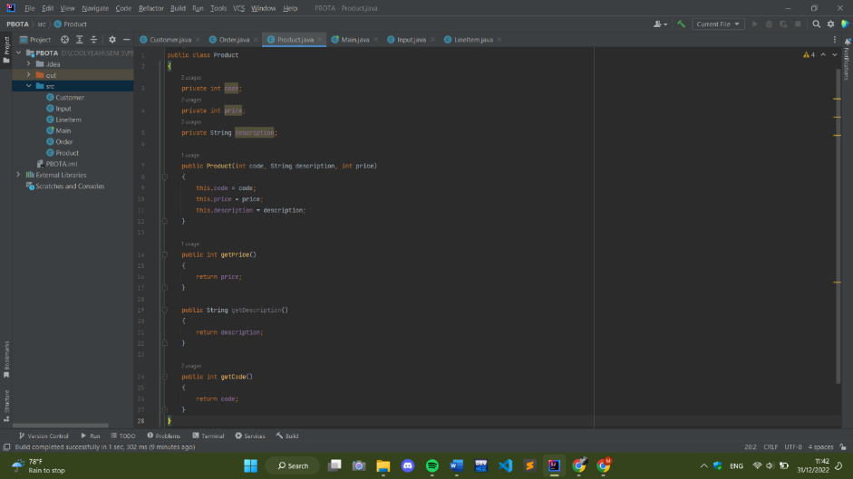

* Order.java

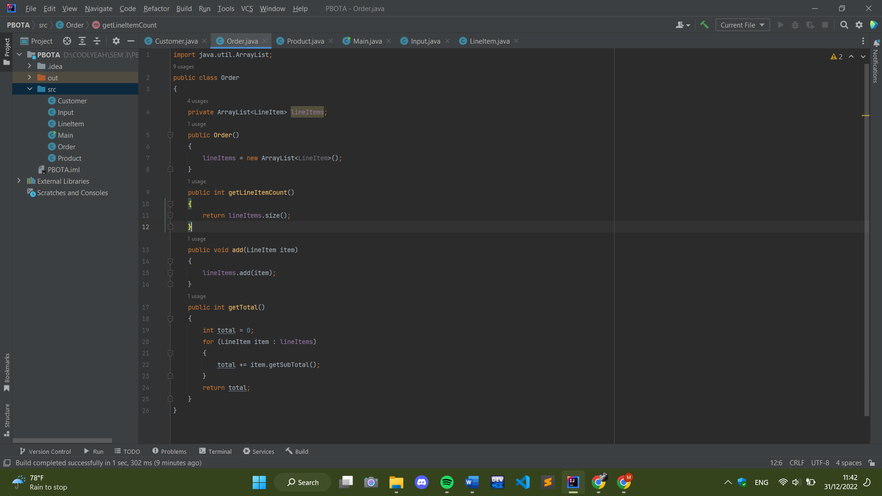

* Main.java

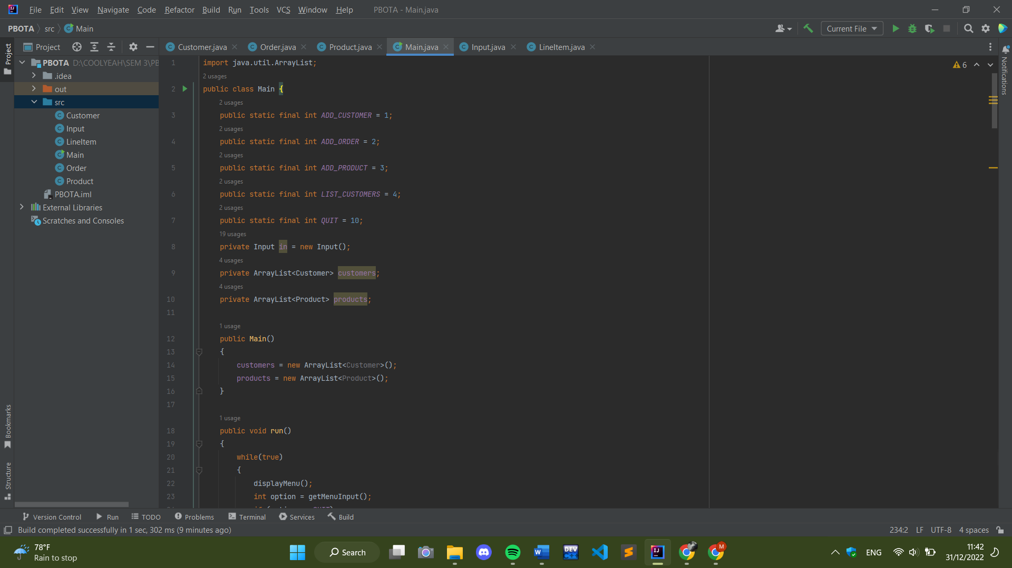

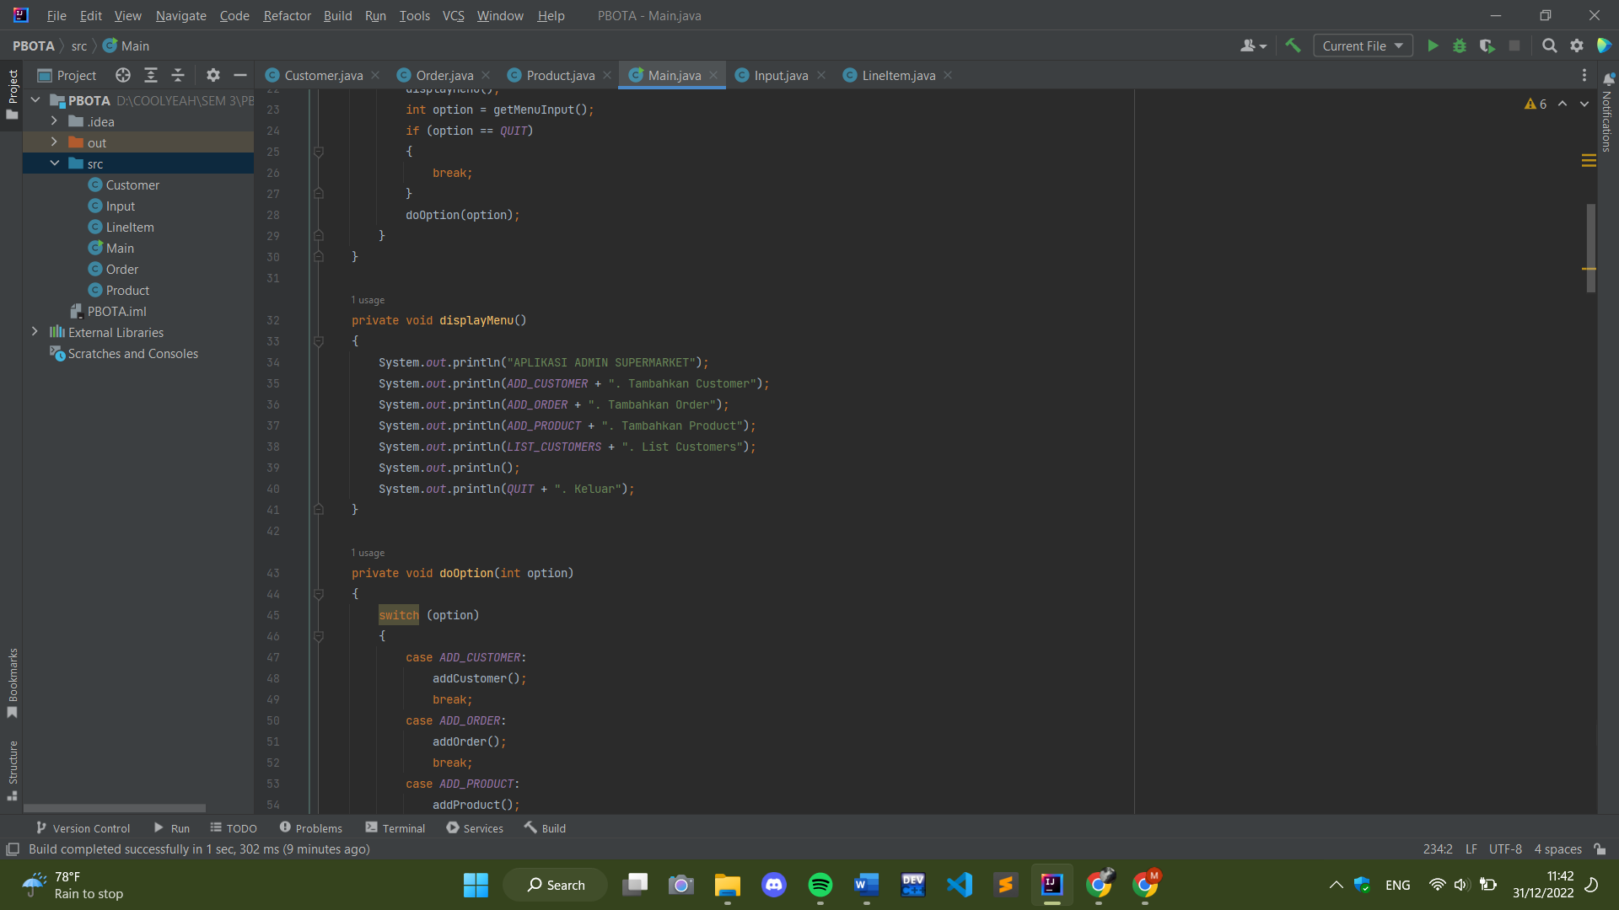

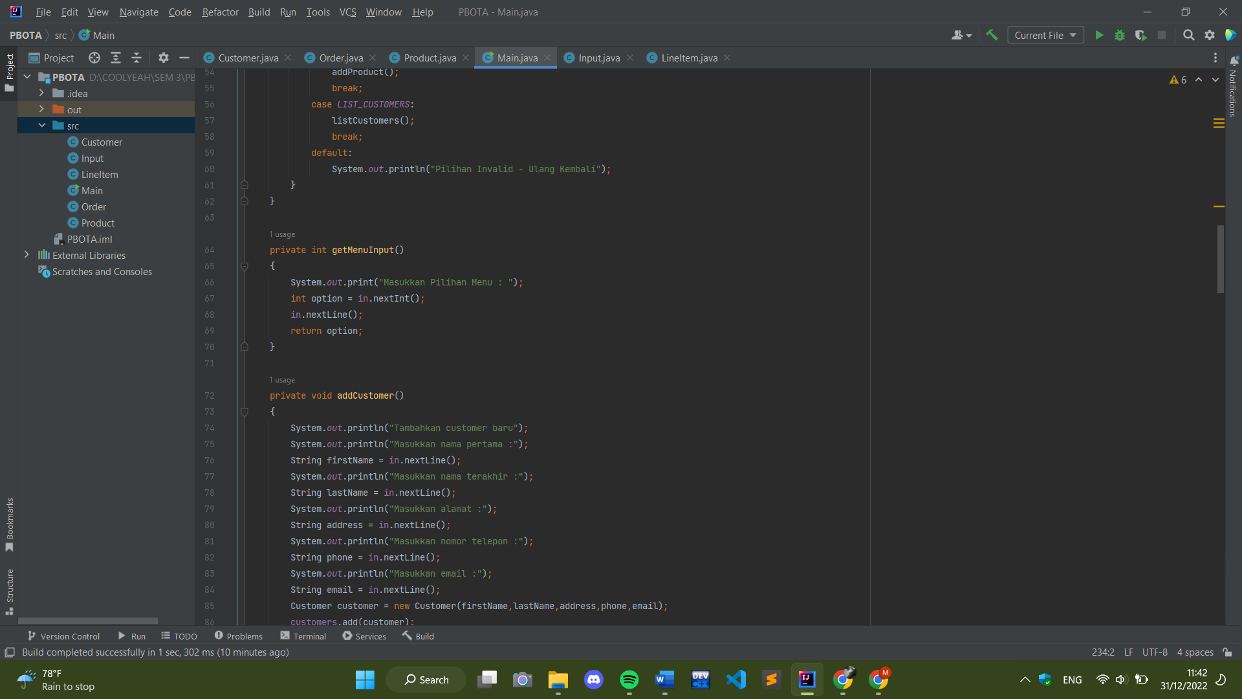

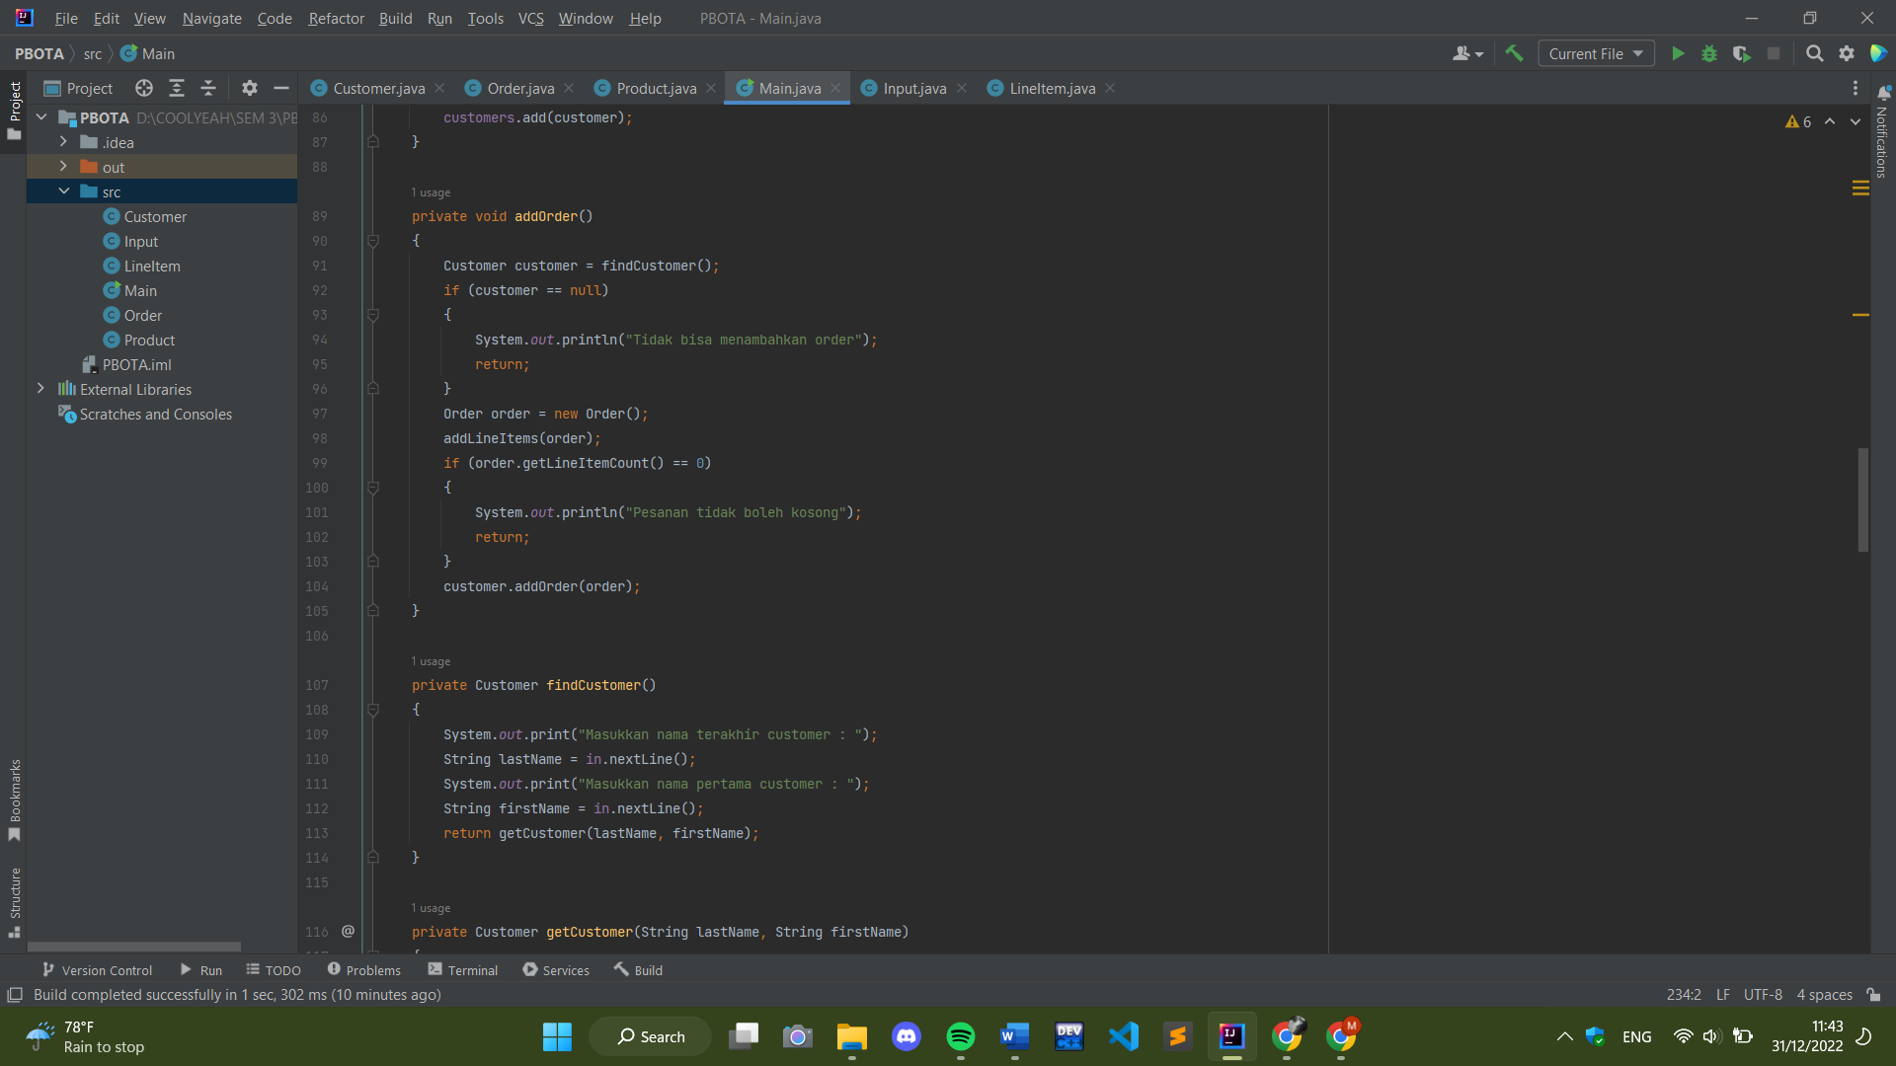

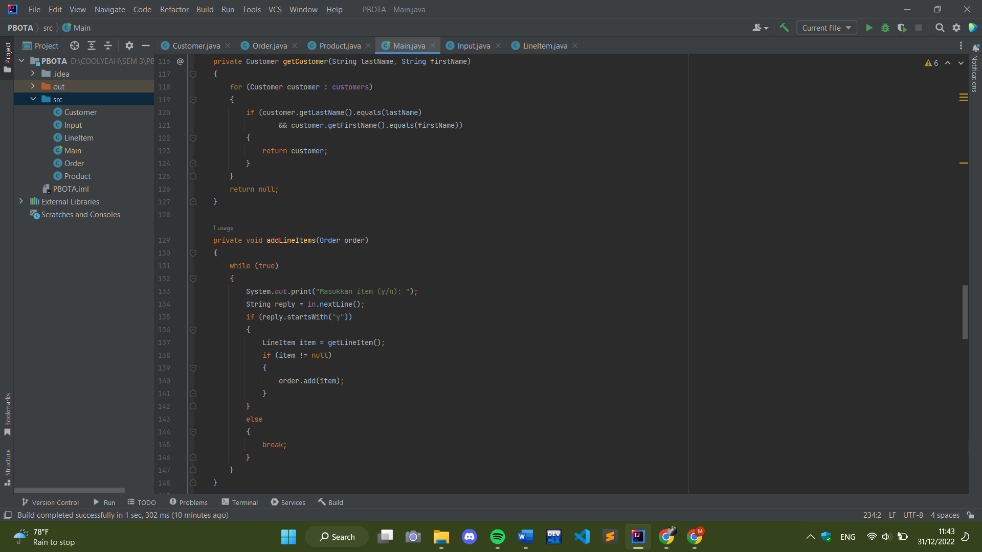

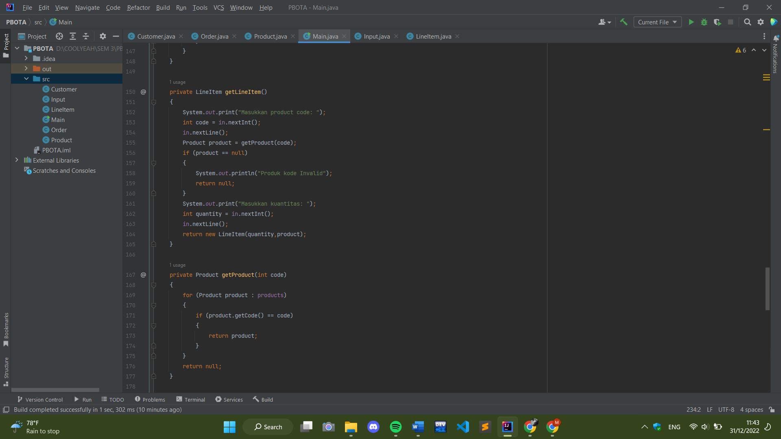

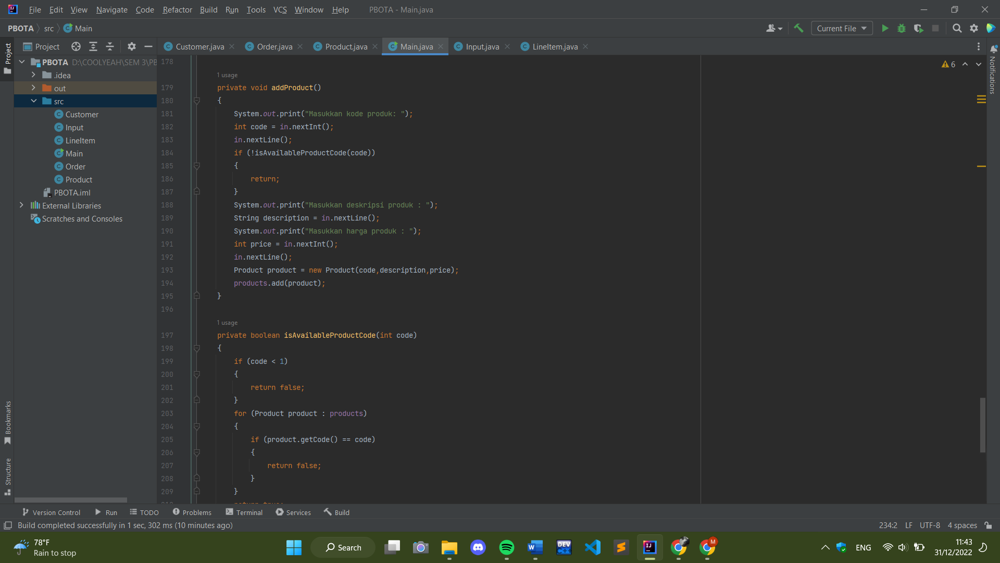

1. **Teks source code**

* Customer.java

1. **import** java.util.ArrayList;
3. **public** **class** Customer
4. {
5. **private** String firstName;
6. **private** String lastName;
7. **private** String address;
8. **private** String phone;
9. **private** String email;
10. **private** ArrayList<Order> orders;
12. **public** Customer(String firstName, String lastName, String address, String phone, String email)
13. {
14. **this**.firstName = firstName;
15. **this**.lastName = lastName;
16. **this**.address = address;
17. **this**.phone = phone;
18. **this**.email = email;
19. orders = **new** ArrayList<Order>();
20. }
22. **public** String getFirstName()
23. {
24. **return** firstName;
25. }
27. **public** String getLastName()
28. {
29. **return** lastName;
30. }
32. **public** String getAddress()
33. {
34. **return** address;
35. }
37. **public** String getPhone()
38. {
39. **return** phone;
40. }
42. **public** String getEmail()
43. {
44. **return** email;
45. }
47. **public** **void** addOrder(Order order)
48. {
49. orders.add(order);
50. }
52. **public** ArrayList<Order> getOrders()
53. {
54. **return** **new** ArrayList<Order>(orders);
55. }
57. **public** **int** getTotalForAllOrders()
58. {
59. **int** total = 0;
60. **for** (Order order : orders)
61. {
62. total += order.getTotal();
63. }
64. **return** total;
65. }
66. }

* Order.java

1. **import** java.util.ArrayList;
2. **public** **class** Order
3. {
4. **private** ArrayList<LineItem> lineItems;
5. **public** Order()
6. {
7. lineItems = **new** ArrayList<LineItem>();
8. }
9. **public** **int** getLineItemCount()
10. {
11. **return** lineItems.size();
12. }
13. **public** **void** add(LineItem item)
14. {
15. lineItems.add(item);
16. }
17. **public** **int** getTotal()
18. {
19. **int** total = 0;
20. **for** (LineItem item : lineItems)
21. {
22. total += item.getSubTotal();
23. }
24. **return** total;
25. }
26. }

* Product.java

1. **public** **class** Product
2. {
3. **private** **int** code;
4. **private** **int** price;
5. **private** String description;
7. **public** Product(**int** code, String description, **int** price)
8. {
9. **this**.code = code;
10. **this**.price = price;
11. **this**.description = description;
12. }
14. **public** **int** getPrice()
15. {
16. **return** price;
17. }
19. **public** String getDescription()
20. {
21. **return** description;
22. }
24. **public** **int** getCode()
25. {
26. **return** code;
27. }
28. }

* LineItem.java

1. **public** **class** LineItem
2. {
3. **private** **int** quantity;
4. **private** Product product;
6. **public** LineItem(**int** quantity, Product product)
7. {
8. **this**.quantity = quantity;
9. **this**.product = product;
10. }
12. **public** **int** getQuantity()
13. {
14. **return** quantity;
15. }
17. **public** Product getProduct()
18. {
19. **return** product;
20. }
22. **public** **int** getSubTotal()
23. {
24. **return** product.getPrice() * quantity;
25. }
26. }

* Input.java

1. **import** java.io.Closeable;
2. **import** java.io.InputStream;
3. **import** java.util.InputMismatchException;
4. **import** java.util.Iterator;
5. **import** java.util.NoSuchElementException;
6. **import** java.util.Scanner;
8. **public** **class** Input **implements** Closeable, Iterator<String>
9. {
10. **protected** Scanner scanner;
11. **public** Input()
12. {
13. **this**(System.in);
14. }
15. **public** Input(**final** InputStream in)
16. {
17. scanner = **new** Scanner(in);
18. }
20. **public** **void** close()
21. {
22. scanner.close();
23. }
25. **public** **boolean** hasNext()
26. {
27. **boolean** returnValue = **false**;
28. **try**
29. {
30. returnValue = scanner.hasNext();
31. }
32. **catch** (IllegalStateException e)
33. {
34. illegalStateExceptionHandler();
35. }
36. **return** returnValue;
37. }
39. **public** String next()
40. {
41. String returnValue = **null**;
42. **try**
43. {
44. returnValue = scanner.next();
45. }
46. **catch** (NoSuchElementException nsee)
47. {
48. noSuchElementHandler();
49. }
50. **catch** (IllegalStateException ise)
51. {
52. illegalStateExceptionHandler();
53. }
54. **return** returnValue;
55. }
57. **public** **void** remove()
58. {
59. }
61. **public** **int** nextInt()
62. {
63. **int** returnValue = 0;
64. **try**
65. {
66. returnValue = scanner.nextInt();
67. }
68. **catch** (InputMismatchException ime)
69. {
70. inputMismatchExceptionHandler("int");
71. }
72. **catch** (NoSuchElementException nsee)
73. {
74. noSuchElementHandler();
75. }
76. **catch** (IllegalStateException ise)
77. {
78. illegalStateExceptionHandler();
79. }
80. **return** returnValue;
81. }
83. **public** String nextLine()
84. {
85. String returnValue = **null**;
86. **try**
87. {
88. returnValue = scanner.nextLine();
89. }
90. **catch** (NoSuchElementException nsee)
91. {
92. noSuchElementHandler();
93. }
94. **catch** (IllegalStateException ise)
95. {
96. illegalStateExceptionHandler();
97. }
98. **return** returnValue;
99. }
101. **private** **void** illegalStateExceptionHandler()
102. {
103. System.err.println("Input has been closed.");
104. System.exit(1);
105. }
107. **private** **void** inputMismatchExceptionHandler(**final** String type)
108. {
109. System.err.println("Input did not represent " +
110. (type.equals("int") ? "an" : "a") + " " + type + " value.");
111. System.exit(1);
112. }
114. **private** **void** noSuchElementHandler()
115. {
116. System.err.println("No input to be read.");
117. System.exit(1);
118. }
119. }

* Main.java

1. **import** java.util.ArrayList;
2. **public** **class** Main {
3. **public** **static** **final** **int** ADD_CUSTOMER = 1;
4. **public** **static** **final** **int** ADD_ORDER = 2;
5. **public** **static** **final** **int** ADD_PRODUCT = 3;
6. **public** **static** **final** **int** LIST_CUSTOMERS = 4;
7. **public** **static** **final** **int** QUIT = 10;
8. **private** Input in = **new** Input();
9. **private** ArrayList<Customer> customers;
10. **private** ArrayList<Product> products;
12. **public** Main()
13. {
14. customers = **new** ArrayList<Customer>();
15. products = **new** ArrayList<Product>();
16. }
18. **public** **void** run()
19. {
20. **while**(**true**)
21. {
22. displayMenu();
23. **int** option = getMenuInput();
24. **if** (option == QUIT)
25. {
26. **break**;
27. }
28. doOption(option);
29. }
30. }
32. **private** **void** displayMenu()
33. {
34. System.out.println("APLIKASI ADMIN SUPERMARKET");
35. System.out.println(ADD_CUSTOMER + ". Tambahkan Customer");
36. System.out.println(ADD_ORDER + ". Tambahkan Order");
37. System.out.println(ADD_PRODUCT + ". Tambahkan Product");
38. System.out.println(LIST_CUSTOMERS + ". List Customers");
39. System.out.println();
40. System.out.println(QUIT + ". Keluar");
41. }
43. **private** **void** doOption(**int** option)
44. {
45. **switch** (option)
46. {
47. **case** ADD_CUSTOMER:
48. addCustomer();
49. **break**;
50. **case** ADD_ORDER:
51. addOrder();
52. **break**;
53. **case** ADD_PRODUCT:
54. addProduct();
55. **break**;
56. **case** LIST_CUSTOMERS:
57. listCustomers();
58. **break**;
59. **default**:
60. System.out.println("Pilihan Invalid - Ulang Kembali");
61. }
62. }
64. **private** **int** getMenuInput()
65. {
66. System.out.print("Masukkan Pilihan Menu : ");
67. **int** option = in.nextInt();
68. in.nextLine();
69. **return** option;
70. }
72. **private** **void** addCustomer()
73. {
74. System.out.println("Tambahkan customer baru");
75. System.out.println("Masukkan nama pertama :");
76. String firstName = in.nextLine();
77. System.out.println("Masukkan nama terakhir :");
78. String lastName = in.nextLine();
79. System.out.println("Masukkan alamat :");
80. String address = in.nextLine();
81. System.out.println("Masukkan nomor telepon :");
82. String phone = in.nextLine();
83. System.out.println("Masukkan email :");
84. String email = in.nextLine();
85. Customer customer = **new** Customer(firstName,lastName,address,phone,email);
86. customers.add(customer);
87. }
89. **private** **void** addOrder()
90. {
91. Customer customer = findCustomer();
92. **if** (customer == **null**)
93. {
94. System.out.println("Tidak bisa menambahkan order");
95. **return**;
96. }
97. Order order = **new** Order();
98. addLineItems(order);
99. **if** (order.getLineItemCount() == 0)
100. {
101. System.out.println("Pesanan tidak boleh kosong");
102. **return**;
103. }
104. customer.addOrder(order);
105. }
107. **private** Customer findCustomer()
108. {
109. System.out.print("Masukkan nama terakhir customer : ");
110. String lastName = in.nextLine();
111. System.out.print("Masukkan nama pertama customer : ");
112. String firstName = in.nextLine();
113. **return** getCustomer(lastName, firstName);
114. }
116. **private** Customer getCustomer(String lastName, String firstName)
117. {
118. **for** (Customer customer : customers)
119. {
120. **if** (customer.getLastName().equals(lastName)
121. && customer.getFirstName().equals(firstName))
122. {
123. **return** customer;
124. }
125. }
126. **return** **null**;
127. }
129. **private** **void** addLineItems(Order order)
130. {
131. **while** (**true**)
132. {
133. System.out.print("Masukkan item (y/n): ");
134. String reply = in.nextLine();
135. **if** (reply.startsWith("y"))
136. {
137. LineItem item = getLineItem();
138. **if** (item != **null**)
139. {
140. order.add(item);
141. }
142. }
143. **else**
144. {
145. **break**;
146. }
147. }
148. }
150. **private** LineItem getLineItem()
151. {
152. System.out.print("Masukkan product code: ");
153. **int** code = in.nextInt();
154. in.nextLine();
155. Product product = getProduct(code);
156. **if** (product == **null**)
157. {
158. System.out.println("Produk kode Invalid");
159. **return** **null**;
160. }
161. System.out.print("Masukkan kuantitas: ");
162. **int** quantity = in.nextInt();
163. in.nextLine();
164. **return** **new** LineItem(quantity,product);
165. }
167. **private** Product getProduct(**int** code)
168. {
169. **for** (Product product : products)
170. {
171. **if** (product.getCode() == code)
172. {
173. **return** product;
174. }
175. }
176. **return** **null**;
177. }
179. **private** **void** addProduct()
180. {
181. System.out.print("Masukkan kode produk: ");
182. **int** code = in.nextInt();
183. in.nextLine();
184. **if** (!isAvailableProductCode(code))
185. {
186. **return**;
187. }
188. System.out.print("Masukkan deskripsi produk : ");
189. String description = in.nextLine();
190. System.out.print("Masukkan harga produk : ");
191. **int** price = in.nextInt();
192. in.nextLine();
193. Product product = **new** Product(code,description,price);
194. products.add(product);
195. }
197. **private** **boolean** isAvailableProductCode(**int** code)
198. {
199. **if** (code < 1)
200. {
201. **return** **false**;
202. }
203. **for** (Product product : products)
204. {
205. **if** (product.getCode() == code)
206. {
207. **return** **false**;
208. }
209. }
210. **return** **true**;
211. }
213. **public** **void** listCustomers()
214. {
215. System.out.println("List customers");
216. **for** (Customer customer : customers)
217. {
218. System.out.println("Nama                : " + customer.getLastName()
219. + ", "
220. + customer.getFirstName());
221. System.out.println("Alamat              : " + customer.getAddress());
222. System.out.println("Phone               : " + customer.getPhone());
223. System.out.println("Email               : " + customer.getEmail());
224. System.out.println("Pesanan yang dibuat : " + customer.getOrders().size());
225. System.out.println("Total orders        : " + customer.getTotalForAllOrders());
226. }
227. }
229. **public** **static** **void** main(String[] args)
230. {
231. Main orderSystem = **new** Main();
232. orderSystem.run();
233. }
234. }
235. **Screenshot tampilan luaran program**

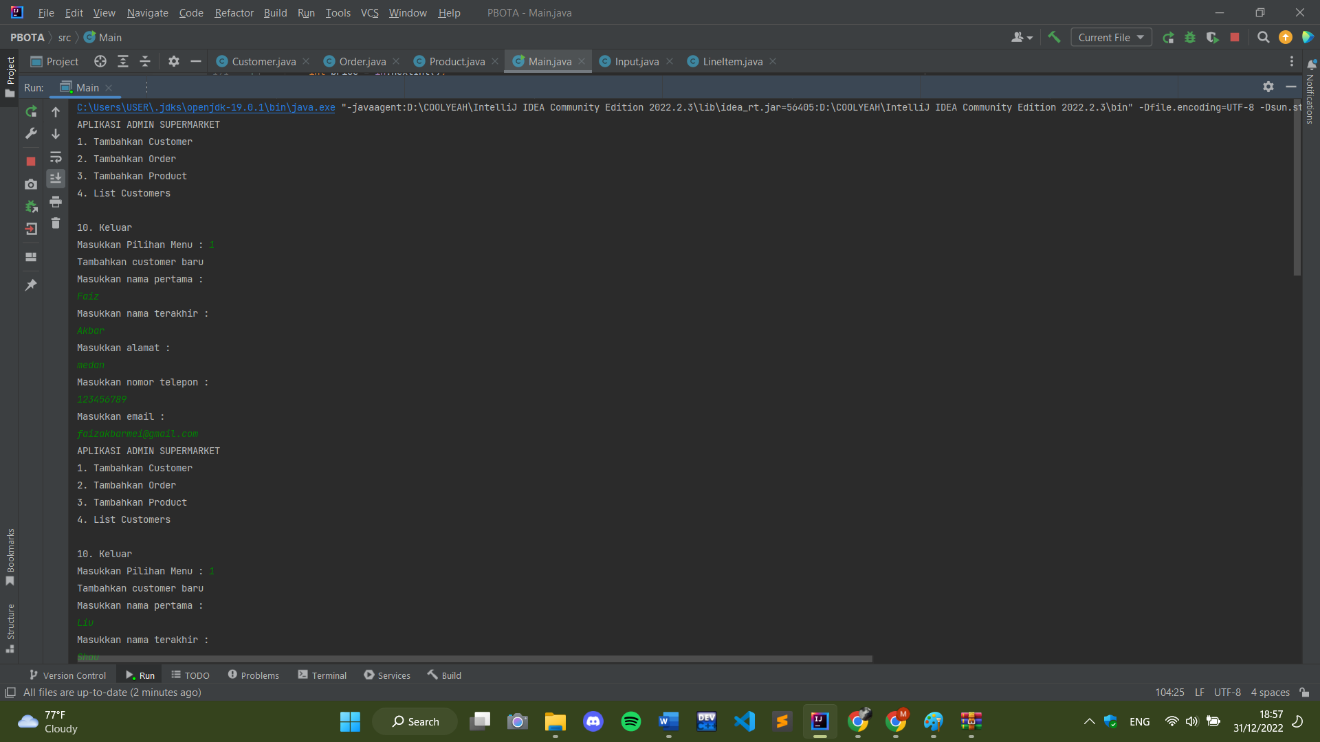

Menjalankan program.

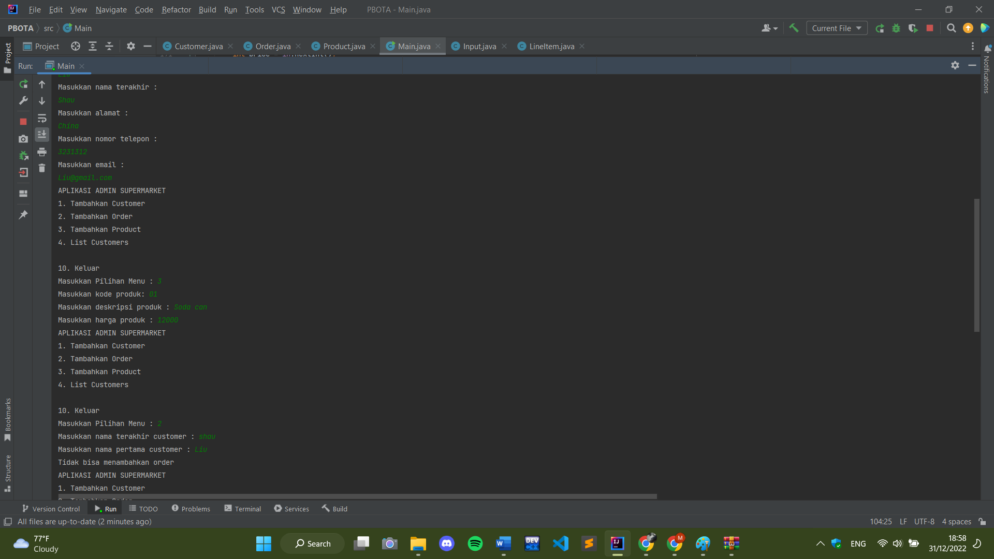

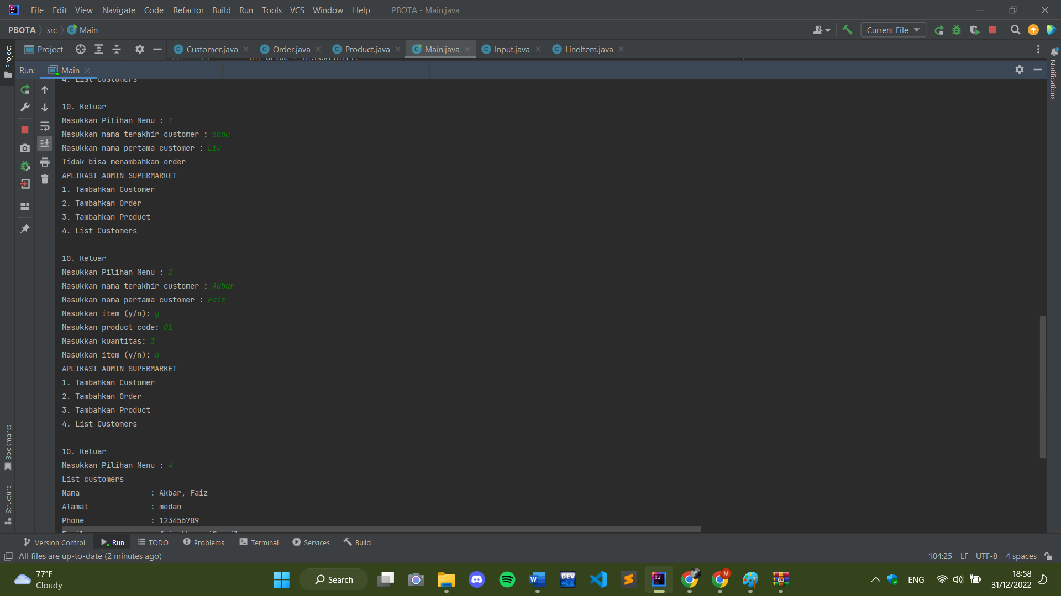

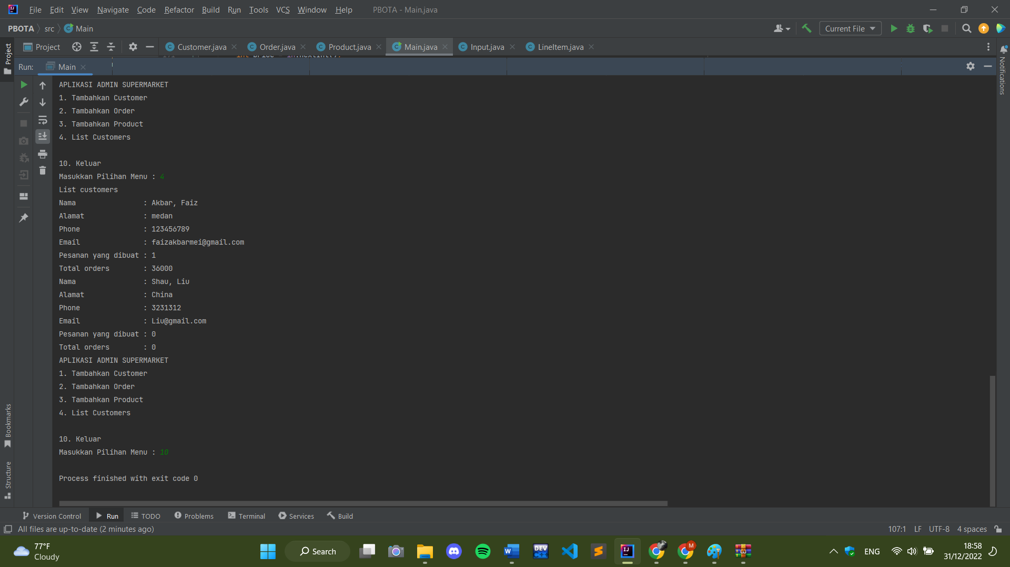

1. **Uji coba program beserta capture eror/sukses**

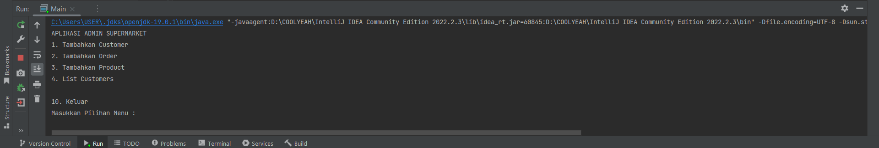

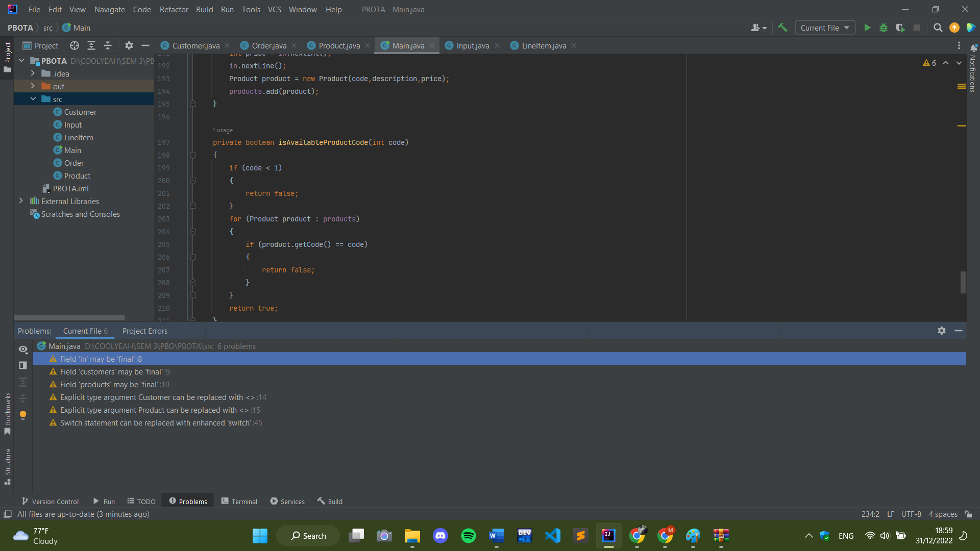

Aplikasi dapat berjalan dan tidak ada error, hanya warning saja.

1. Screenshot tampilan unggahan daftar file di halaman projek Gitlab

